Social Monomania Helpful Documentation

This documentation is to assist the owner of Social Monomania after the students have concluded their time with the project.

|  |
| --- |
| Table of Contents |
| Data Analysis with Microsoft Azure Machine Learning |
| Updating API Key for Reddit |
| Updating API Key for Twitter |
| How to Access the Django Admin Site |
| How to Access the Heroku Back-End Site |
| Instructions for Adding Additional Social Media APIs |
| Helpful Links |

# Data Analysis with Microsoft Azure Machine Learning

Microsoft Excel 2013, and later, has a downloadable sentiment analysis tool called Azure Machine Learning.

1. To begin, open the excel file you wish to perform sentiment analysis on. We are going to use the excel file downloaded from Social Monomania Data Export.

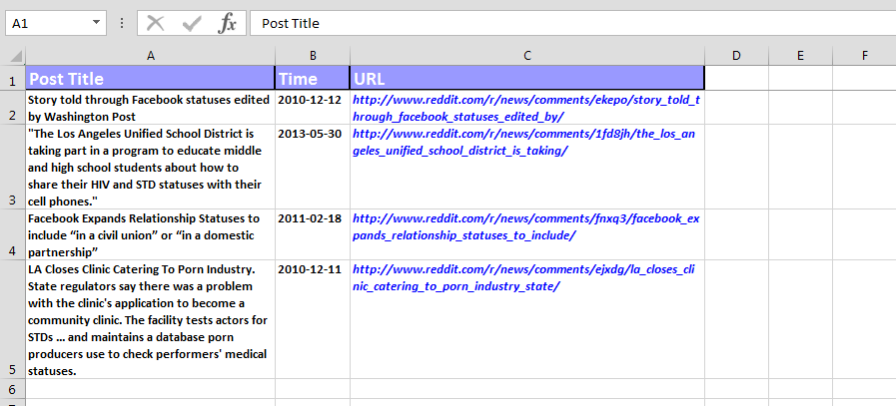

1. To download the add-in, open Excel and go to Insert -> Store in the top ribbon.
   1. Note: To access the add-in in the future, you can click ‘My Apps’ in the ‘Add-ins’ section and select the app from the menu.

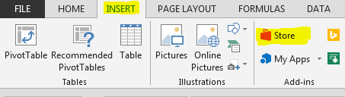

1. On the left toolbar, click ‘Data Analytics’. Click ‘Add’ next to the Azure Machine Learning item.

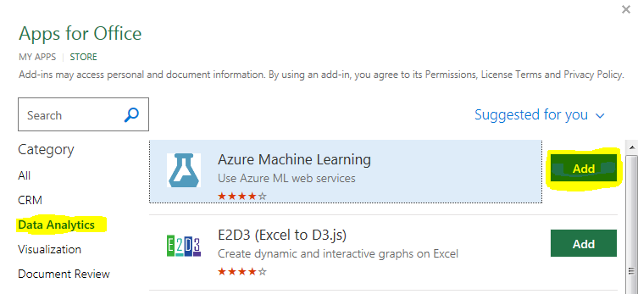

1. The Azure Machine Learning add-in is now added to Excel. It should automatically open on the right-side of your spreadsheet. Click ‘Text Sentiment Analysis (Excel Add-in…’

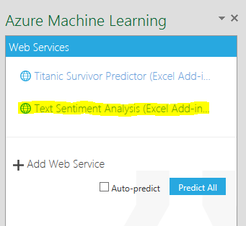

1. Click the ‘Select Data’ button to the right of the first text box.

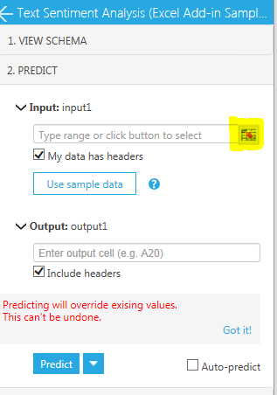

1. Select the cells in the column you want to analyze. It is important that you *do not* include the headers of the column. You will see your cells selected in the ‘Select Data’ box that popped up. ‘Reddit Results’ is the name of the worksheet you’re currently on.

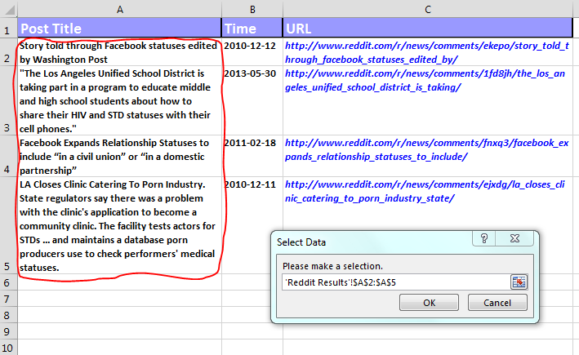

1. Click OK in the ‘Select Data’ box

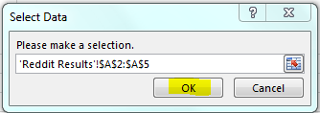

1. Notice in the add-in textbox, it now says ‘Range Selected’ to indicate you have selected a range

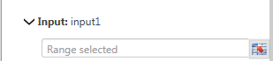

1. Make sure ‘My data has headers’ is unchecked. Type the output cell in the ‘Output’ textbox. For this example, we chose D1. Click ‘Predict’ button

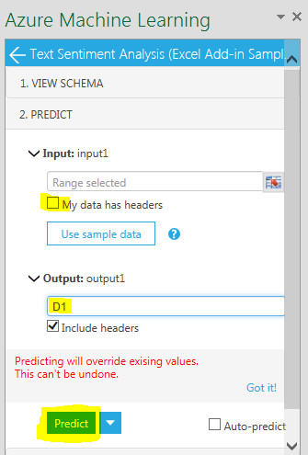

1. To verify these steps were performed properly, you will see a bubbling Erlenmeyer flask for a few seconds while the add-in calculates the results.
2. Two columns have been added to the spreadsheet detailing the sentiment analysis.

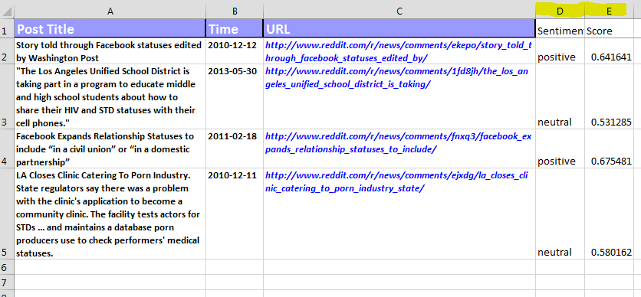

1. The column ‘Score’ gives a number ranging from 0 – 1. The closer to 0, the more negative; the closer to 0.5 is more neutral, and the closer to 1 gives you a positive. The ‘Sentiment’ column is a reflection of this range.
2. There are things you can do with this data, such as sort by ‘Sentiment’, or sort by ‘Score’ to group the results. You can also see them in graph form. To do this, select a column (excluding the headers)

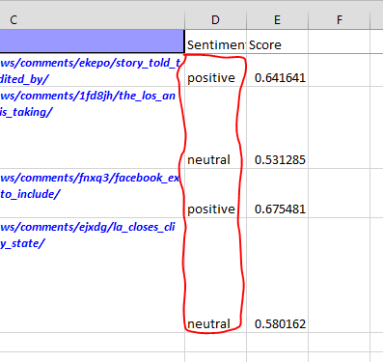

1. On the ‘Insert’ tab on the top ribbon, click ‘Recommended Charts’

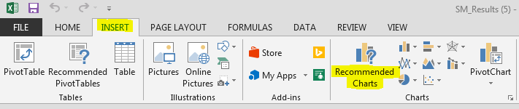

1. This will bring up a list of recommended visual graphs you can choose from

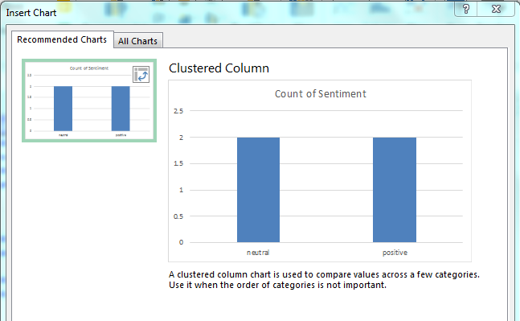

1. Clicking OK will create a new worksheet in your workbook, and show the selected graph along with a key of the data it used

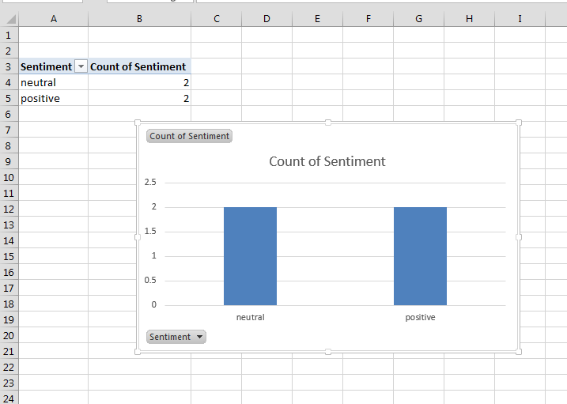

1. This concludes the simple demonstration of the Microsoft Azure Machine Learning add-in tool. For more information, please see the following link:

<https://docs.microsoft.com/en-us/azure/machine-learning/>

# Updating API Key for Reddit

# Updating API Key for Twitter

# How to Access the Django Admin Site

# How to Access the Heroku Back-End Site

# Instructions for Adding Additional Social Media API to Social Monomania

# Helpful Links

Django documentation <https://docs.djangoproject.com/en/2.0/>

Heroku support [https://help.heroku.com](https://help.heroku.com/)

Heroku documentation [https://devcenter.heroku.com](https://devcenter.heroku.com/)